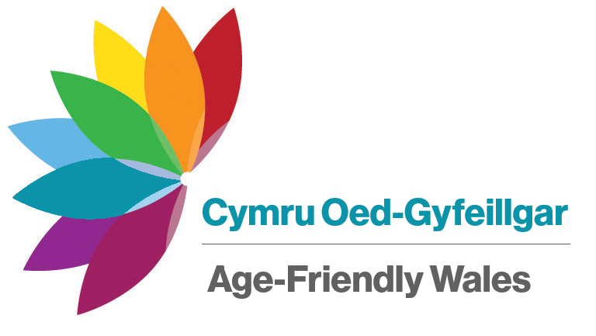 | Newsletter  Summer 2019
Updates on age-friendly communities for members of the Ageing Well in Wales network
Be an Age-Friendly Champion
Help us to make Wales a Wales a nation of age-friendly communities by becoming an Age-Friendly Champion and spreading the word about the Ageing Well Card.
The Ageing Well Cards contain simple messages that can be used to let people know that they might need a little help or support and are provided in a distinctive and practical travelcard wallet. They mean older people can maintain their independence and continue to do the things that matter to them.
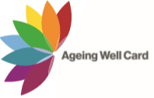
Get in touch if you would like to help make sure the cards are widely recognised or if your organisation would like to become more age-friendly.

Did you know?
- One in three people in Wales will be over the age of 60 by 2025
- Over 65s spend around £1 in every £5 in the UK
- Up to £214 million in Pension Credit and other entitlements went unclaimed in Wales in 2016/17. If you think you or someone you know might be eligible, find out more at https://bit.ly/2LNfIhu or contact the Age UK advice line on 0800 678 1602
Making your community more age-friendly
We will soon be running 5 Age-Friendly Communities events across Wales:
- Welshpool Town Hall on the 18 September
- Theatr Soar, Merthyr Tydfil on the 10 October
- Galeri Caernarfon on 16 October
- Letterston Memorial Hall on 23 October
- National Waterfront Museum, Swansea on 24 October
For more information, contact the Ageing Well team at ageingwell@olderpeoplewales.com or on 03442 640 670.
Making a difference
Is there a cause or issue in your community that is important to you? The Older People's Commissioner can support groups that include older people to plan and get started on any local campaign.
We can provide free practical advice to help you:
- Get the information you need
- Make your campaign stand out
- Reach the public and media
- Influence decision-makers
To find out more, or to book a session with your community group, please get in touch.
Have your say about the Wales you want
Our friends at the office of the Future Generations Commissioner are capturing stories, ideas and suggestions about what people want a future Wales to look like and would love to hear from you. You can take part in “Our Future Wales” online at https://bit.ly/2LAzopJ.
You can contact the Older People’s Commissioner for Wales at:
Cambrian Buildings  Mount Stuart Square  Cardiff CF10 5FL | Phone: 03442 640 670  Email: ageingwell@olderpeoplewales.com  Website: www.olderpeoplewales.com  Twitter: @talkolderpeople

